0

Urban Fieldwork Analysis and Evaluation Report: What Makes Vienna the Great City

Student Name Affiliation
Course Number, Course Name
Instructor’s Name Due Date Wordcount: 2296

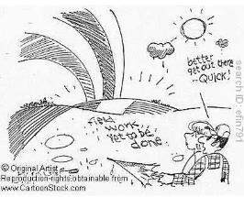

Urban Fieldwork Analysis and Evaluation Report: What Makes Vienna the Great City
Introduction
The study investigates the link between income disparity and the attractiveness of various districts/neighbourhoods. According to the findings, wealthier districts have better-maintained structures and attract more tourists, but lower-income communities provide lower-cost options such as autos. The study intends to remove the stigma against poorer communities and impact policies meant to improve the quality of life for all people, regardless of local income level.

Research question.
To what extent does average inequality depend on the general desirability of a district (as measured by average income)?

Hypothesis
I expect that wealthier districts will have better-maintained buildings than poorer ones, for example Stephansplatz and possibly Taubstummengasse: Influenced by history and richness of these places, affluent areas are more attractive to people and investments. A high- class construction looks appealing to tourists when they choose where to go on vacation.
Cleanliness is important in prestigious locations as rich homeowners would like well-maintained streets.
On the other hand, I anticipate poor districts with lower incomes will attract low prices for their automobiles such as Kagranerplatz and Nestroyplatz : The presence of cars belonging to individuals from the poorer districts, such as Kagranerplatz and Nestroyplatz, can be seen. The rich surround themselves with neighbourhoods they can use to boast about their wealth; therefore, clichéd images of wealth predominate in such areas because motor vehicles are often associated with affluence.

Methodology
The study used Likert scales to assess local disparities in terms of sanitation, cleanliness, accessibility, infrastructure, and diversity among other measures. It aimed at determining the level of unequal distribution on neighbourhood-based standards by analyzing district livability and its relationship with income levels. The data gathered was primarily qualitative, with limited quantitative 'transport versus people' information. The study sought to find inequality tendencies by examining crime distribution, income, access to excellent education,

and life expectancy. This information aids in the reduction of stigma and the implementation of focused initiatives to improve the quality of life for inhabitants.

Data presentation

Locations studied in fieldwork in Vienna.
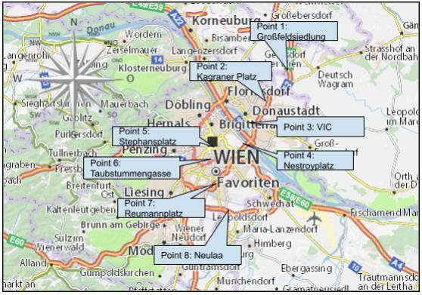

Figure 1: “Landkarte Wien - Stadtplan Wien - ViaMichelin.” annotated with areas that were
investigated in Fieldwork.

Points of locations observed in Vienna.

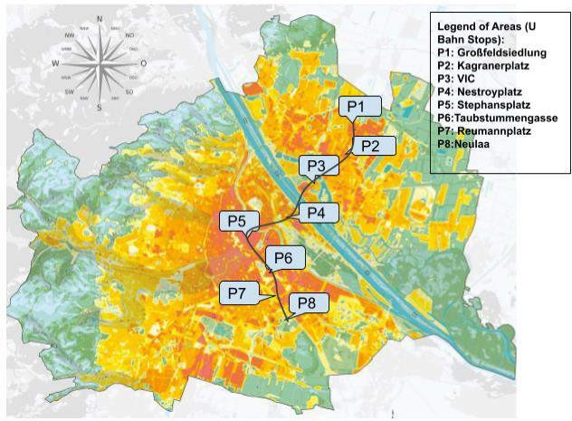

Figure 2: “ORF.at.” Map of the route taken through Viennas Ubahn stops.

Methods of data collection

- Create a Likert table that measures 6 factors that reflect income inequality in Vienna. These
must measure different aspects of urban life in Vienna.

- For each factor create a specification, from 1-5. 1 will always be the poorest condition of the certain aspect and 5 the best and most developed condition of the aspect.
- The control variable in this research expedition is the 6 aspects being measured, the area where the aspects are being measured, therefore outside the U Bahn station, and the people recording the data.
- The dependent variable will be the level of the six aspects being measured in the Likert scale,
which will reflect the spread of income inequality in Vienna.

- The independent variable is the area and u bahn station in Vienna, this will show how the change in area reflects the dependent variable.
  - The group members travel with the U1 to the Uhabn stop, the first stop Großfeldsiedlung
  - Step outside the station, take images and walk in distance around the area.

  - Measure the levels of each factor and record it in the likert scale.

  - Repeat 1-3

  - In the end, there should be 8 completed Likert scales (one for each station)
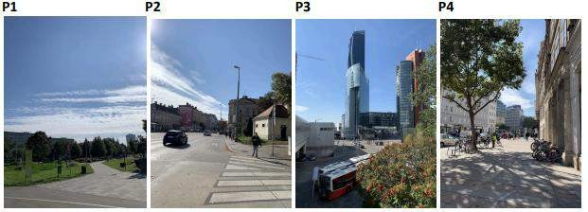
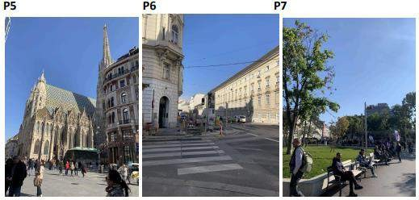
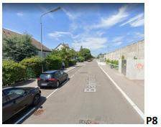

Justification

The study used a Likert scale and firsthand photos to analyze income disparity in Vienna.
The data was collected through Likert scale analysis and images. The study also analyzed secondary data by graphing greenery levels against a city map. My colleagues and I used images, observations, research, and personal knowledge to assign percentages of greenery to each place. The study found outliers that better reflect inequality in Vienna, and our understanding of uneven regions helped us to make informed decisions. The study provides a comprehensive understanding of income disparity in Vienna.
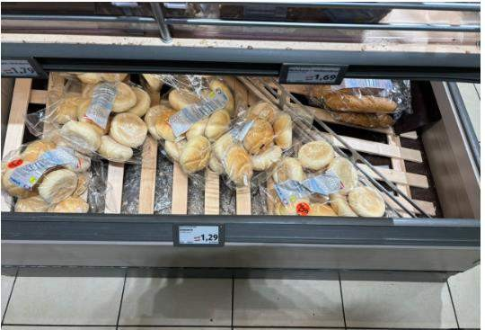
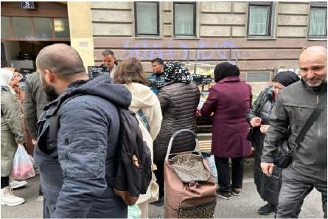

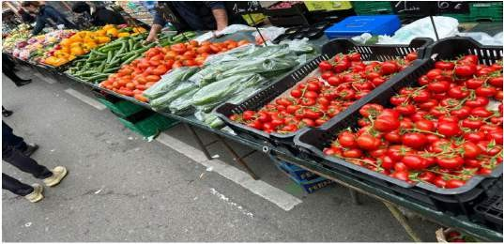

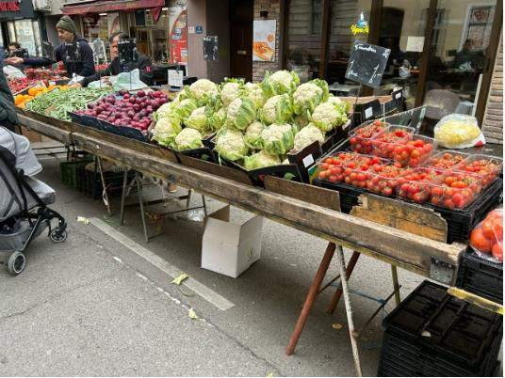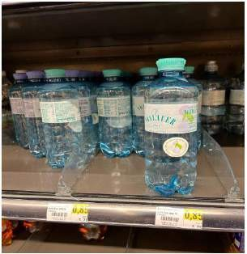

Data Presentation, Processing, and Analysis

Data Presentation

- Primary Data

Inequality Indicators measured in a likert scale.

1= Worst measure of the aspect in the given location 5 Best measure of the aspect in the given location
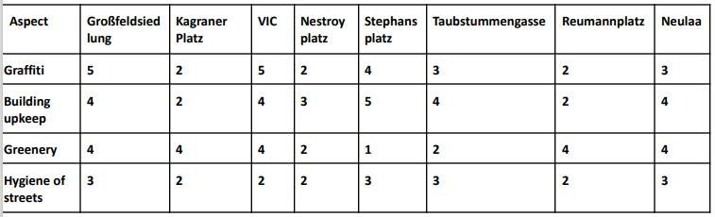
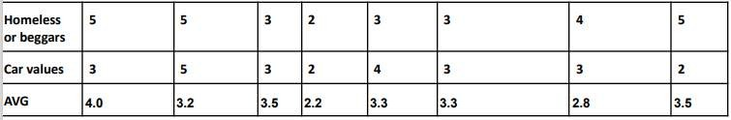

Secondary Data

Follow this link to access the data: https://docs.google.com/document/d/1rXGkhhnqcHCpSD_9seqEkIunwJIQJm9- XqXjUZ9KUAg/edit

Greenness level expressed in percentage in the various areas researched.
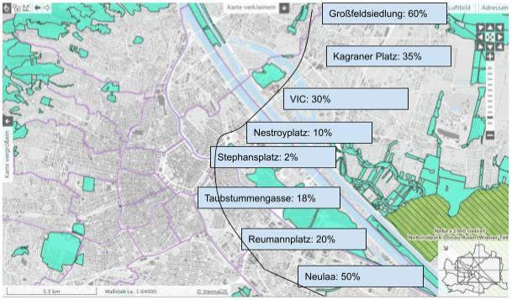

Figure 3: “Offizielle Statistik Der Stadt Wien.” Greenery mapped as a percentage of each
district.

This is a qualitative data collection and presentation I have created with quantitative data.
The data range from 0-100%, the higher the percentage the greener the area, this is displayed against a map of Vienna, with the city’s judgement of its greenness. My observations are also backed up with the data from the Likert scales that match these mapped values. I can also prove this with my other form of secondary data which also justifies my percentages and my photographs.

Mapped indicator of income inequality in response to the Likert scale

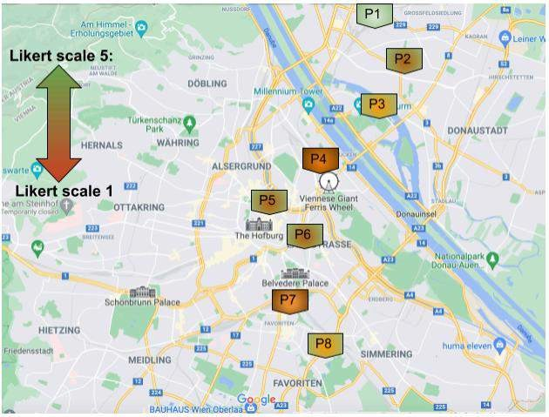

Figure 4: “Google maps” average Likert scale value of each area

The graph shows an average income inequality level in Vienna, with colour markers ranging from 1 to 5. However, it does not accurately represent the region's income disparity trends. Stephansplatz and Taubstummengasse have high income levels but decrease due to a lack of environmental considerations. High-income areas have less vegetation and higher homelessness, while areas with more vegetation are less affluent. The graph also shows income segregation in quantified but unquantifiable features, with high-income neighbourhoods having more homeless individuals and beggars. The graph's ineffective use of Likert scales makes it difficult to accurately analyze the region.

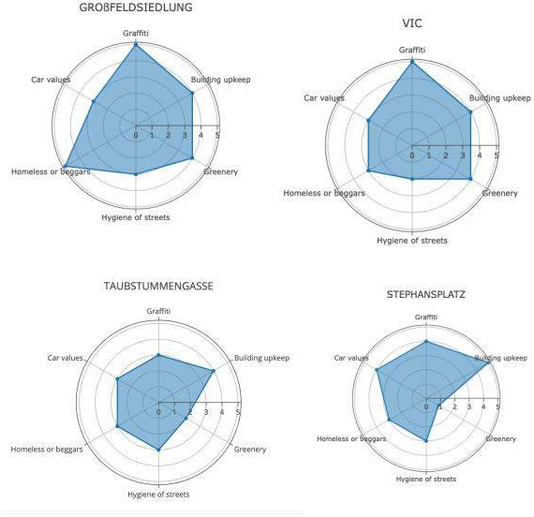
Figure 5: Self-created radar graphs of each area

Radar plots provide insight into a city's revenue distribution by comparing measurable variables. The various radar plots may be used to identify patterns in the locations, as well as places with comparable income disparity. For example, VIC and Großfeldsieldung have higher ratings for graffiti, vegetation, and building care, but lower ratings for automobile value and street hygiene. Unlike Stephansplatz and Taubstummengasse, which have similar shapes, have high values in cars, values, building care, and minimal vegetation. These three elements are opposed for various net-income districts, indicating segregation. Although building upkeep is high in various net income locations, it might lead to anomalies and rely significantly on secondary data. Reumannplatz and Kagranerplatz are examples of poorer communities with insufficient building care, indicating inadequate housing management.

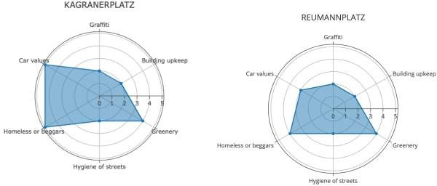
The prevalence of contemporary and new houses in VIC is associated with lower income due to lesser maintenance costs compared to antique and Viennese properties. As a result, buildings in Neulaa are similarly highly praised, but they are classified as "Viennese." Social structures indicate lesser income and inequality. The care of a property might reflect inequalities faced by individuals. The radar maps at VIC, Neulaa, and Großfeldsiedlung show contemporary and hygienic homes for low-income individuals to compensate for the high cost of city living.
The lack of facilities in these regions contributes to low rates of graffiti and homelessness. This percentile has limited access to top schools and higher commuting costs, resulting in lower vehicle values, further perpetuating inequality.
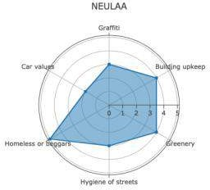
Nonetheless, there is one identifiable anomaly: Nestroyplatz's radar. The data indicates low values across all dimensions, but when compared to the real income level of the population, district, and area, it contradicts the genuine net worth. As previously mentioned, it has the lowest Nestroyplatz located at the beginning of the city centre and is considered a wealthier region based on data points. Nestroyplatz is a combination of classical and neglected altbau, resulting in a 3 rating for building

care. However, the other criteria are directly related to this judgment.

The lack of vegetation in the city centre stems from its role as a link between the impoverished and the wealthy. This area is experiencing an increase in beggars, poor street cleanliness, and graffiti. Located near a prestigious location, this area provides both affordable and luxurious home options. Families that have access to schools, city lodgings, and transportation (Nestroyplatz serves as a connection) are less likely to face inequality traps.
Although it appears cleaner, this does not indicate a trap, but rather a measure of median income.
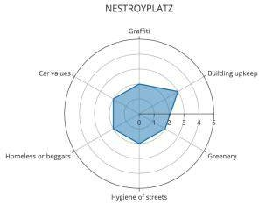
challenging due to the presence of more diverse income levels. (However, practical inaccuracy also adds to the radar's form, since we did not explore this area for an extended length of time, preventing us from seeing the distance throughout this location.)

However, identifying inequality traps in middle-income communities might be

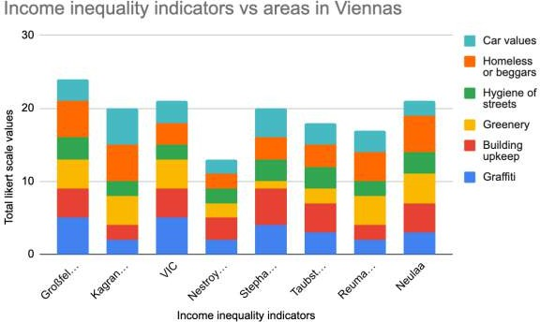

Figure 6: Self-made bar chart expressing the total inequality value of Likert scales

In every one of these areas, the Histogram show the pictorial propositions that are about the inequality proportional heights. The y-axis shows how many and less the area suffered or had this problem. Akin to this, it has similarly been posited for many years. The size mirrors the indicator variable onto the graph along with the bad outcome (as if they are walking).
Different totals share lots of values above all locations. At this point, this trace is amazing. One of the parties that characterize the need within our area is the fact that 19.5 stands out in terms of financial distribution (see below). Although the case study indicates to an extreme level, it is important to understand that Likert scale data limitation as well. The judgments in the case must be understood as the alignment of those ratings with the rest of the independent contributors as well. Digitized datasets may also be incorporated into the presentation. As an example, pay attention to things you have not given much importance such as type of buildings, net worths per district and where the cars are located As such an indicator can help provide more information about the place than a y-axis catches.
Another telling detail from the chart is that the bars have almost the same height so there is little variance in income distribution which accounts for Vienna’s low index of income inequality. Divided from the best, however, Nestroyplatz is situated in an area with an average

income rates within Vienna which even exceeds all other districts in terms of prosperity standards. The film did not show those areas, for instance, Großfeldsiedlung and Neulaa, as they were mostly proposed by secondary data photographs to have been clean and beggar-free. Vienna directly puts resources into affordable accommodation to meet its multifaceted society. Whilst Stephansplatz could not do any better in this field, Kagranerplatz made donation beggars flourish. In the evolving varied socioeconomic capital of the different districts of Vienna, the study concludes that there are no noticeable trends and the score on the metrics being examined is also uniformly spread out that justice at all levels is served well.

Change in average income by locations researched from 2002 to 2011.
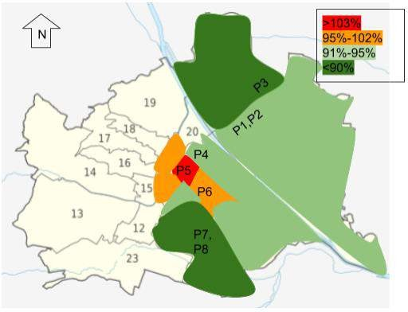
Figure 7: “Kadi, Justin.” mapped wage changes in districts investigated
This map shows nine years of wage growth in Vienna's GÃ¼rtel district and highlights inequality in the city. In Region 1 (P5) the average salary increased by 3%, while in other regions it increased by 2% or decreased by 5%. Vienna's high cost of living and number of tourists are the opposite. However, the city is trying to prevent economic conflicts in surrounding areas and improve poor neighbourhoods through planting and modern housing.

Districts investigated vs Average income per district about the GDP.

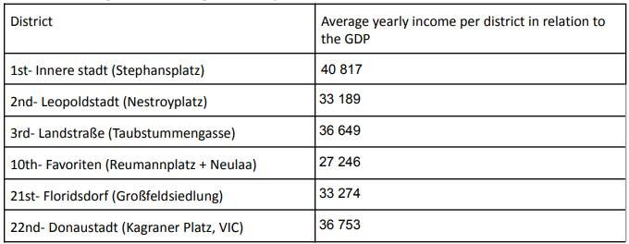
Figure 8: “Lohnsteuerpflichtige Einkommen Nach Bezirken 2018 Frauen Und Männer - Offizielle Statistik Der Stadt Wien.” Table of the average yearly income per district about the GDP

Conclusion
The study also revealed that the maintenance and cleanliness of streets were higher in high-income localities with an average score of 3 out of 5. However, some low-income areas had new and modern buildings as a result of redevelopment schemes implemented to counter the image deficiency, along with Vienna's efforts to achieve urban equality and sustainability.
Classical antiquarian Vienna constructions were in the best condition due to their significance in historical culture. Concerning cars, there was no clear correlation between income levels and car prices, but pricier cars were more on display in wealthier districts. Based on the findings, it can be inferred that urban planning is employed by Vienna to reduce inequality and ensure a high quality of life, making it an excellent and sustainable city. Nonetheless, lower-ranked issues such as homelessness, graffiti, and crime should not be ignored, and increased police surveillance and improved safety measures can be implemented in areas with lower income.

Evaluation
The archive in Vienna provides a comprehensive study of non-standard structures, identifying areas of importance and requiring further attention. Research issues regarding primary and secondary data, personal information, biases, and background information are less clear. This document turned out to be very useful and important for inequality studies in Vienna. However, weaknesses were identified in the study and data collection. Earnings depend heavily on subjective and secondary data, so more than a Likert scale is needed. Various measures can be taken to improve the level of employment, education, and migration. Additionally, the actual rental value of the property will help detect anomalies and improve the quality of the data.

Works Cited
“Landkarte Wien - Stadtplan Wien - ViaMichelin.” MICHELIN, www.viamichelin.at/web/Karten-Stadtplan/Karte_Stadtplan-Wien-1004-Wien- Osterreich.
Banabak, Selim, Justin Kadi, and Antonia E. Schneider. "Gentrification and the suburbanization of poverty: evidence from a highly regulated housing system." Urban Geography (2024): 1-23. www.wien.gv.at/statistik/arbeitsmarkt/tabellen/einkommen-gesamt-bez.html.

